# JumpBus User Manual

1. User enters the home address, workplace address and the time they want to leave. These parameters will be saved as the user’s profile, the application will provide the best travel solution based on the real-time data everyday.

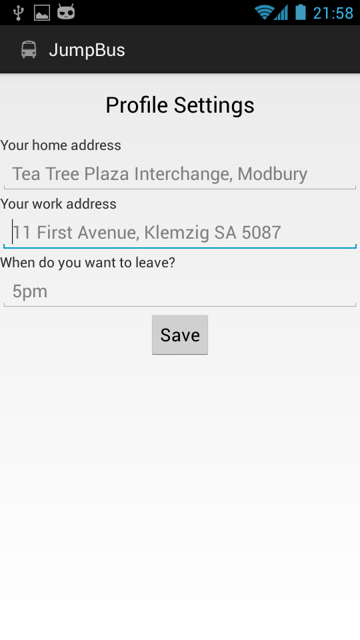

1. Click on save, your profile will be saved, then the best solution is provided with star on the side.

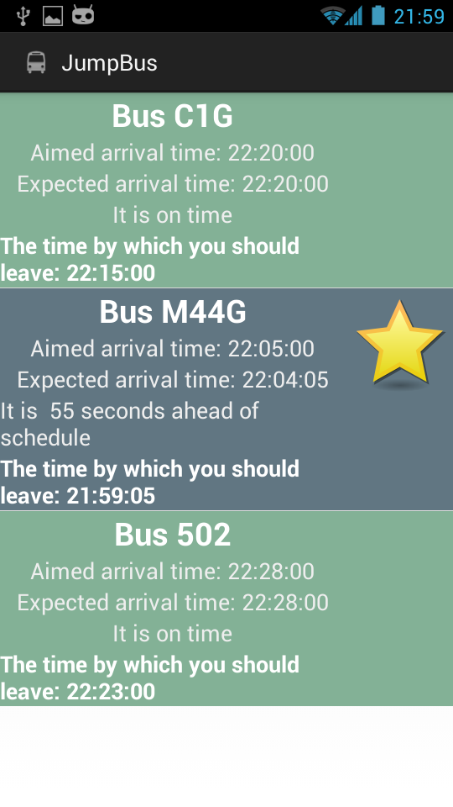

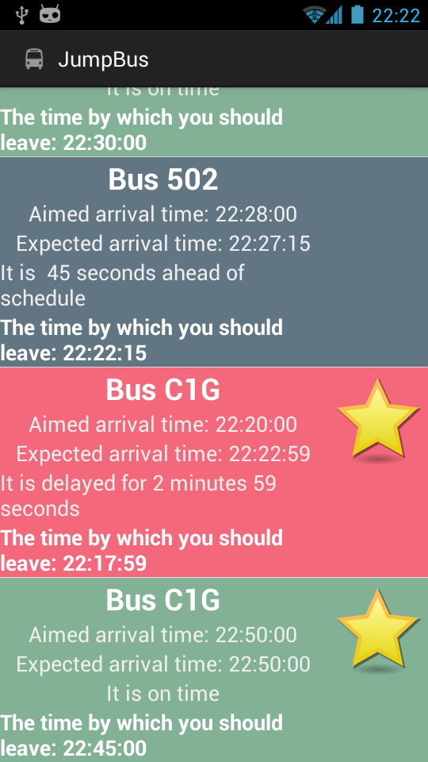

The different color indicates the punctuality of each bus.

1. Touch the solution you want, a dialog pop up displaying more information about the bus, such as driver’s reference number.

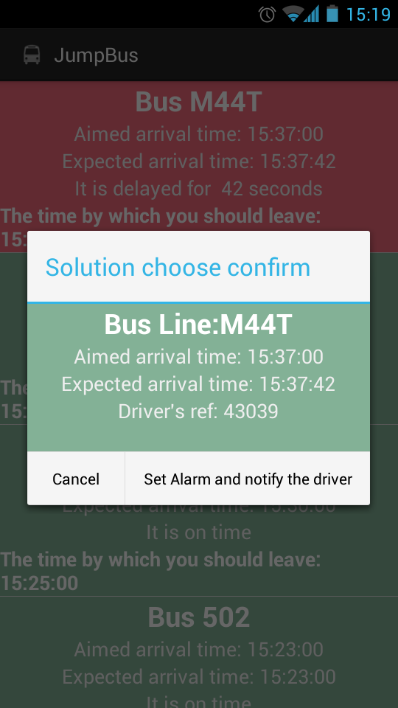

1. Click on Set Alarm and notify the driver if you want to accept this solution.

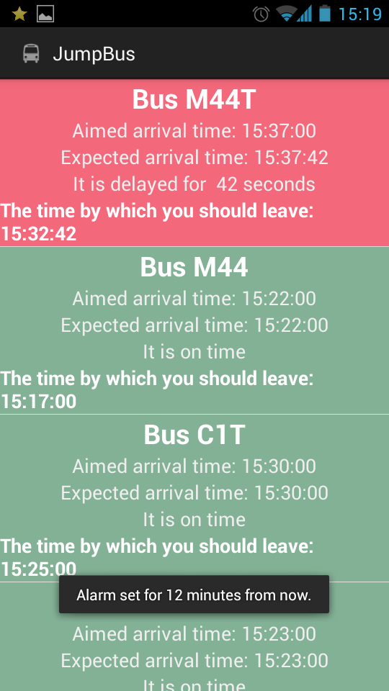

The alarm will be set to secure your departure time.

1. You will get real-time notification about your bus information.

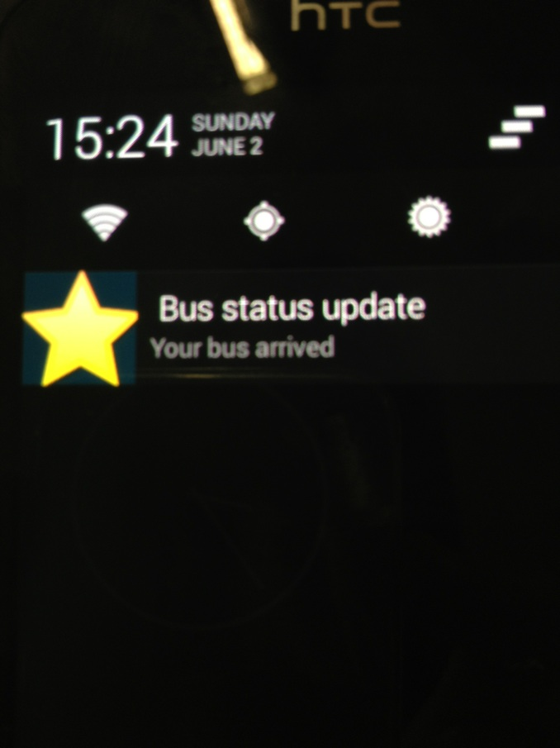

This update can be seen at the phone’s notification center.

1. Click on the notification, you will get the chance to rate the driver’s service or request the driver to wait for you if you are about to arrive at the stop by touch the request wait button.

